5.116: a) Differentiating twice, 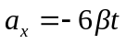 and 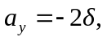 so
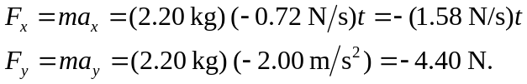
b)
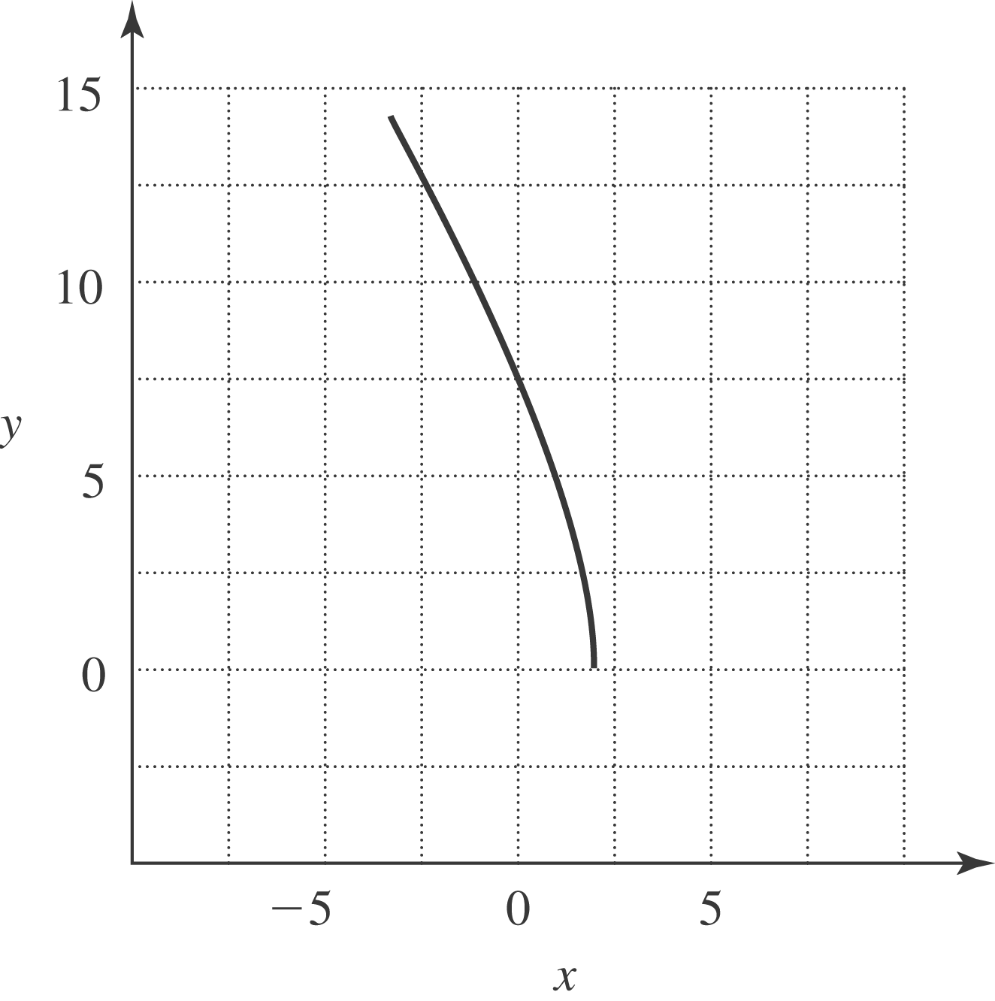

c) At so
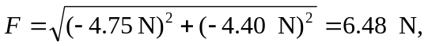
at an angle of 